## How to implement this in the devicelist

### Introduction

To implement all the devices in the devicelist we will now give an example on the basis of the single-line drawing we presented earlier. We will try to give you a method that is easy to use, yet with the least possibilities to make any mistakes. Once you get familiar with the devicelist, you can derive your own method of working. The ultimate goal of the devicelist is to make the topology connected flawlessly which can be checked in NavVision.

### The devices

As seen earlier a device name is “Identification of the device where the sensor/control or serial device is connected to. This text should be unique for each FT NavVision® device. The text is case sensitive”

So to use it later on in the sensorlist it is mandatory that you give each device a name that is unique. So use names as “GPS” or “Port Engine” or any other name as long as it is descriptive for your device.

As the example single line drawing shows we have two servers that are in the topology. For now let’s call them Server 1 and Server 2. So the first devices that we put into the devicelist are these two. Please remember wich one you call Server 1 and which Server 2 (easiest way to do is to write it down in the drawing). Now let’s put them in the devicelist (see Figure 10‑3).

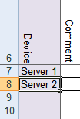

Figure 10‑3: Filling device column 1

Next thing we find in the drawing are a lot of switches. We can number the switches or give them the location as a tag, or even both. That way we know later on about which switch we are talking. In this case we work with the descriptive name and we get the following:

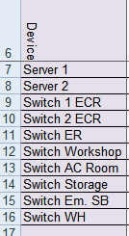

Figure 10‑4: Filling device column 2

Next we take the Wago’s. Lets also take the descriptive name for that and we get the following:

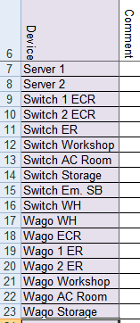

Figure 10‑5: Filling device column 3

Last items are some serial Lan interfaces and some DAP’s (Duty Alarm Panels). Adding these makes the device column complete and gives the following result:

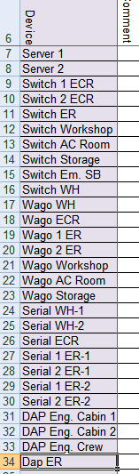

Figure 10‑6: Filling device column 4

*:Serial Lan’s have multiple ports as well as some other interfaces. Make sure you put both ports (if in use) in the device column. You can give it a name like “serial 1 ER-1”wich is the first port of the first serial Lan interface in the engine room, or you can name it after the sensor or device that is connected to that port (in this case “Port Generator”). We prefer the first option because sometimes you have multiple GPS’s on the system or whatever and you will get confused.*

This completes the filling of the device column. If you compare it to your drawing, you can see that all the devices in the topology are now in the devicelist. Time to move to the next column.

### Comment

We leave this up to you. If you have something you need to remember with a certain device you can keep it here. NavVision doesn’t use this information.

### Location

The location is the Identification of the substation where the sensor/control is connected to in the FT NavVision® system. You can easily get that from the drawing and put it in the Location column. In our case we will get the following:

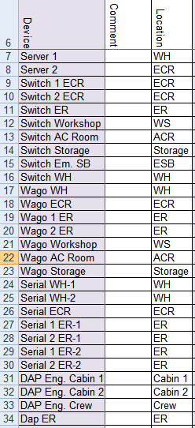`

Figure 10‑7: Filling location column

### Protocol

To choose the protocol you have a lot of options. To make it easy there is a drop-down box. Just click the appropriate field and look in de drop-down menu if you can find the right protocol. (for explanation on the options see Table 10‑2).

The first ones are easy. We have two server and a couple of switches and Wago’s. The protocols for these are quite clear. Fill them in and you get the following:

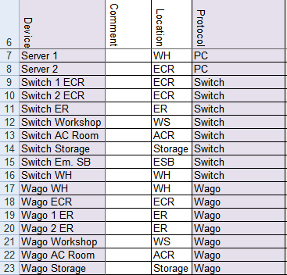

Figure 10‑8: Filling protocol column 1

For the serial Lan’s we need to know what is connected. Look at the drawing and find the right protocol for the connections you see there. For example the GPS and Autopilot are NMEA, the generators and engines are Caterpillar and the printer is a printer. Find these protocols in the drop-down menu and you’ll get the following:

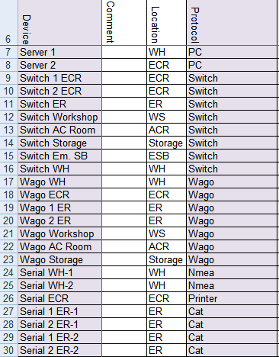

Figure 10‑9: Filling protocol column 2

The DAP’s are PC’s so that ends the filling of the protocol column as follows:

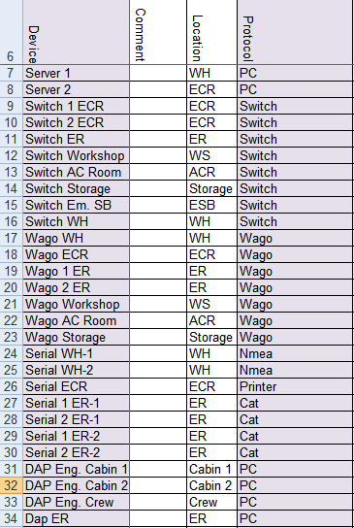

Figure 10‑10: Filling protocol column 3

### Interface

The interface is the name of the sort of interface that is used to get the data into the system. This is used to distinguish the same sort of interfaces by a separate number.

It speaks for itself for most of the interfaces. Only notice that the PC’s will be divided into Servers and Clients and for an interface that has multiple ports you need to add the same interface for each port. (for options see Table 10‑3).

The result will be as follows:

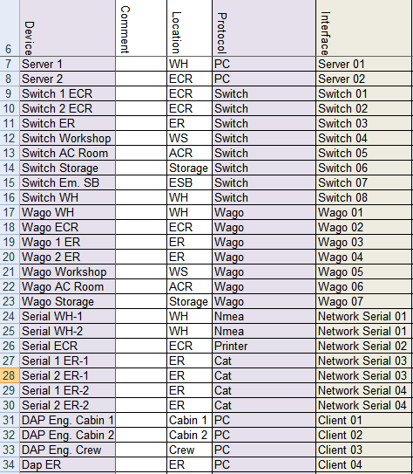

Figure 10‑11: Filling interface column

### Port and Source

The port defines the port on the device that the sensor or whatever is connected. So in our case for example we have a port and a stbd engine that are both connected to the same Serial Lan. While they are separately connected one will be on port 1 and one will be on port 2. In this “Port” column you can specify this as follows:



Figure 10‑12: Port and Source 1

As you can see, the first port on the Serial Lan gets number 1 and the second port gets number 2. In this case the “source” will stay at number 1.

Normally the Port and Source will be “1”

This will result in the following list:

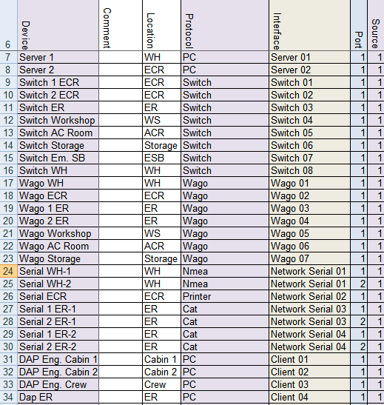

Figure 10‑13 Port and Source 2

*: The source can be as high as 256. When, for instance, you have Modbus/TCP connected through a serial Lan it is possible that there are multiple devices connected through the same bus. The ID’s of these devices can also be put in the “source” column.*

### Type

defines the type of module used to read/control the I/O. (for options see Table 10‑4). As you can tell from the options table it is mostly used when the i/o source is connected to the FT system through some type of interface. This can be Serial Lan, TCP/IP (Modbus or Serial) and a few more options.

Keep in mind that this is part of the interface-side in the sensorlist/devicelist. If the interface needs some extra specification, you will put it here. Most of the fields will be head on what it says but as you may have noticed earlier the Network Serial interface will need some additional information. This is directly shown when you choose Network Serial, the fields “type, speed, datalink and hardware” will change color (see Figure 10‑14).

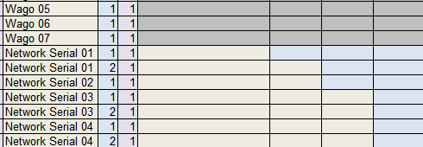

Figure 10‑14: Network Serial colors

In our example, while we do not have any special interfaces, it is quite obvious what to choose. Only some extra information will be needed for the Network Serial. The rest will look like the following:

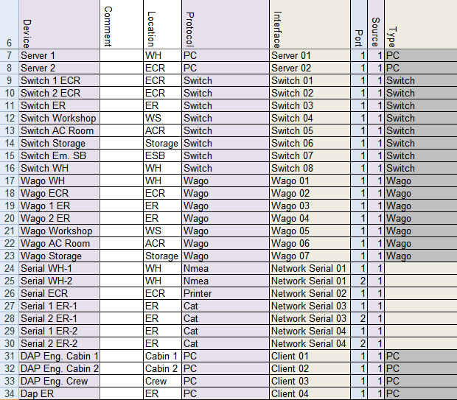

Figure 10‑15: Filling Type column 1

For the Network Serial you will have to look at the Interface in the same way you do as in the rest of the “Type” column. Only in this case it will probably be a serial to Ethernet interface that will go here. You can’t get that directly from the single line drawing, so you need to find out up front. In this example all the network serial interfaces are Moxa’s so we will fill that in. This results the Type column as follows:

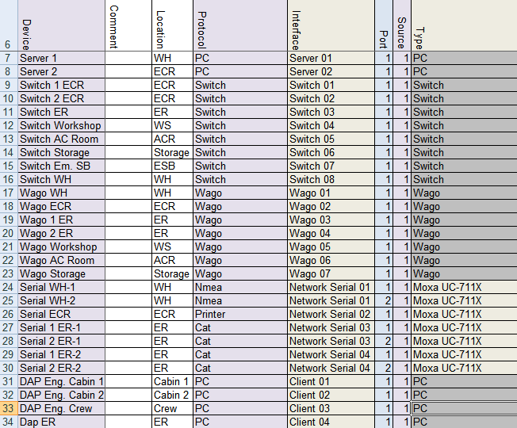

Figure 10‑16: Filling type column 2

### Speed, Datalink and Hardware

The speed, datalink and hardware are figures that you will find in the manuals of the attached sensors, engines, i/o or whatever. If a GPS is connected to the Serial interface, you probably Will find a paragraph describing that it is NMEA, at a speed (baudrate) of 4800. None parity, eight data bits and 1 stop bit and that the serial connection is RS232. (see FT Port Connections and Protocols manual for more information)

This is the data that you need for these columns. NavVision will set the ports on the devices, accordingly to what you put here. Make sure that you have the data ready before starting to build the devicelist.

On the basis of our example drawing we know the following:

* GPS 9600 None 8 1 RS232
* Autopilot 115200 None 8 1 RS232
* Printer 9600 None 8 1 RS232
* Generator 115200 None 8 1 RS485
* Engines 115200 None 8 1 RS485

So with this we can finish these columns and we get the following:

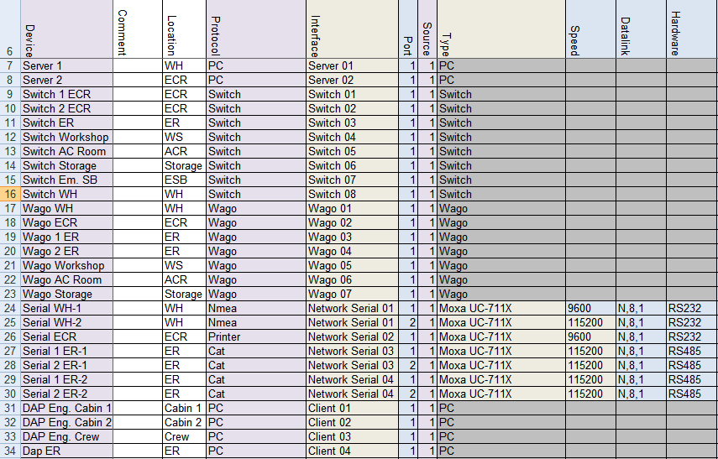

Figure 10‑17: speed, datalink and hardware

### Options

Some devices need some special attention. Mostly because they have another interpretation on protocols, or just that their interpretation deviates from the one that Free Technics uses. To make it easier we have made a separate column where we can put those differences. (for options see Table 10‑5). You can use more options on one device. Just put them in the same cell “comma separated”.

### IP addresses and MAC addresses

As described earlier in Chapters 10.3 and 10.4, we now need to put in the diverse IP addresses and MAC addresses to let the system know how everything is connected. This is essential because the system needs to know where to transfer requests and to make sure that the system is connected the right way. Also the alarms on lost connections depends on these figures.

Let’s look back at the single line drawing that we made (see Figure 10‑1). We already gave the Up-link the number 1 and the Down-link the number 2. These are two separate rings an so they will get a separate IP-range. For the Up-link we start with 172.16.x.x.

Based on our drawing we state that the WH-pc has the key 2637 and the ECR-pc has the key 2636. In this case we can fill in the x.x with the key number. While we always start in the direction of the i/o we will start at the ECR-pc. The ECR-pc port 1 (Up-link) will get the IP address from the first IP range ending with the key number. In this case that will be 172.16.26.36. This address we put in the IPAddressUp behind the Server 2 (see Figure 10‑18).



Figure 10‑18: Addresses and connection 1

From port 1 at the ECR pc we come at a switch in the ECR. As we use the single line drawing as our reference, it is easier that we fill in the devicelist as we follow the main lead of this drawing instead of filling the IP addresses one by one following the order in the devicelist. This will also give you a good indication on any mistakes that you might have made in the devicelist.

So the next column we now will look at is the “connection” column. Here you need to put the device that the server 2 is connected to. In this case that will be the “Switch 1 ECR” as we named that switch in the “device” column (see Figure 10‑19).



Figure 10‑19: Addresses and connection 2

As we connect from the Up-link from one device to the Down-link of the other device, we now that we connect Server 2 Port 1 to the Switch 1 ECR Port 2. So in column “ConnectionPort” We type “2” (see Figure 10‑20).



Figure 10‑20: Addresses and connection 3

As we mentioned, we will follow the single line drawing. So the next row that we will process is the row of the “Switch 1 ECR”. A switch doesn’t have an IP address nor a MAC address is needed. This only leaves us to fill in where a switch is connected at. Following the drawing we see that the “Switch 1 ECR” is connected to the “Switch 2 ECR”. So in this case we need to fill in that it is connected to “Switch 2 ECR” at Port 2 (the Down-link of that switch). This way we come to the following:



Figure 10‑21: Addresses and connection 4

As you can see in the single line drawing, the main ring is connected through a bunch of switches until you come to the WH server. So the rest of the rows are quite the same. After filling in all the switches you will get to the following:

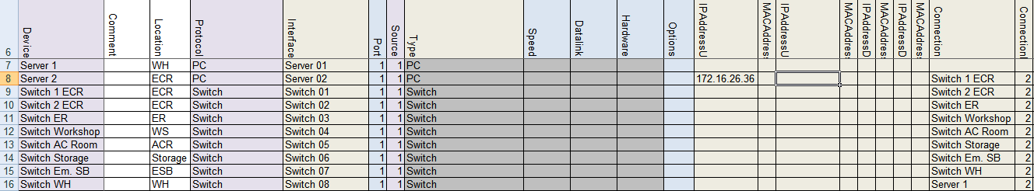

Figure 10‑22: Addresses and connection 5

From the last switch we come to the WH Server or as in the devicelist “Server 1”. This is the tricky part. As you find in the single line drawing, that switch is connected to Port 2 of the Server. As we mentioned earlier, the Up- and Down-link are two separate rings. These rings need to go round all the way. So the Port 2 of the WH server has to be in the same IP-range. With the key number of the WH sever being 2637 the IP address of that port will have to be 172.16.26.37. Now while this is Port 2 on the WH server (the Down-link) you will have to put that IP address in the “IPAddressDown” column. See the following figure:

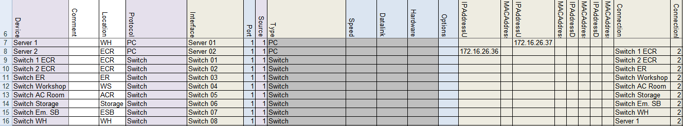

Figure 10‑23: Addresses and connection 6

So now the ring is completed. You can use the devicelist to check if the lines are correct.

Next thing we do is close the ring in the opposite direction. This will be the next IP-range, so 172.17.x.x.

Starting again with the Server 2 the ECR server We are going to address the Down-link port or Port 2 of that server. While it has the key 2636 the IP address for that will be 172.17.26.36 and has to be filled in at the “IPAddressDown” column at the Server 2 row. See following:

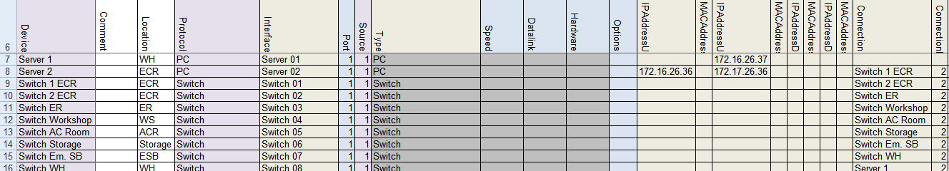

Figure 10‑24: Addresses and connection 7

Concluding that it is connected to Port 1 on the WH server (Server 1) we can now say that the IP address in the “IPAddressUp” column at the Server 1 row must be 172.17.26.37. See following:

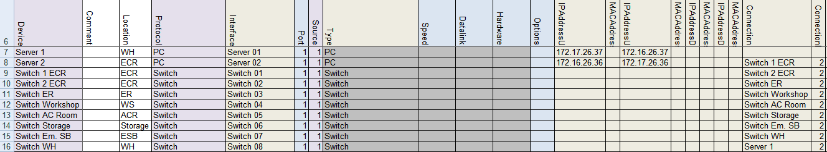

Figure 10‑25: Addresses and connection 8

Now the circle is really connected properly and NavVision can calculate all the connections etc.

#### Other devices

The other devices such as Wago, Network Serial and Clients will not have a Down-link (unless they are in a double-wired systems which goes beyond the scope of this manual), but they do need an IP address, a connection port and sometimes a MAC address.

Let’s start at the Wago. As we saw in Table 10‑6 the Wago use the IP range x.x.1.9y. While the connection lies in the 172.16.x.x range the first Wago will get the address 172.16.1.91, the second Wago will get the address 172.16.1.92 etc. Resulting for our example in the following:

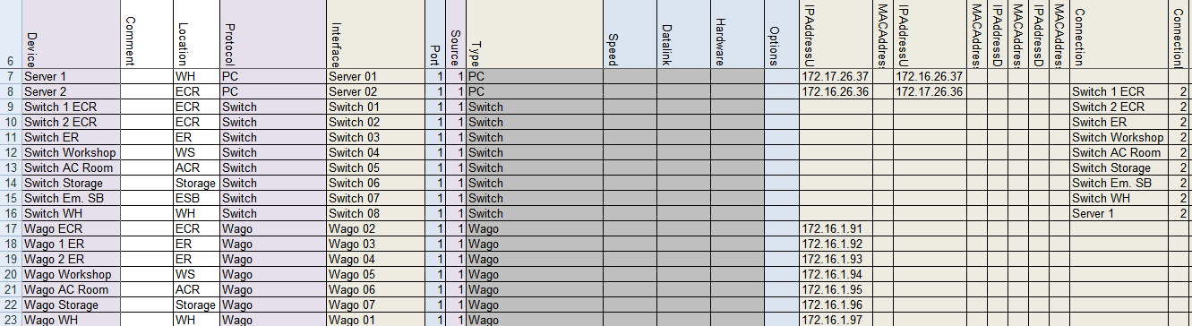

Figure 10‑26: Wago Addresses 1

Wago does need a MAC address but is doesn’t have a Down-link. The MAC address can be found on the Wago PLC itself and will probably lie in the range of 0030DE. Fill in the MAC address in the appropriate row. Also we do need to fill in where they are connected at. For that we again use the single line drawing. As we started earlier at the ECR server we now start again in the ECR and go clockwise to find all the Wago’s. There is one Wago in the ECR (that is why it gets the address 172.16.1.91) and it is connected at the “Switch 2 ECR”. The first free port at the switch is port 3. This results in the following:

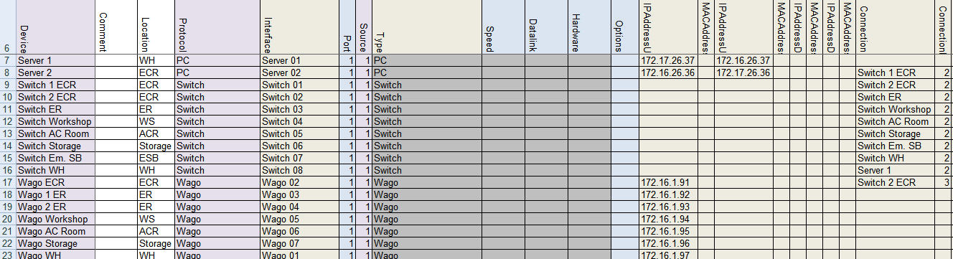

Figure 10‑27: Wago Addresses 2

*: NavVision calculates all the port 1 connections itself. So it is not possible that you find a “1” in the “ConnectionPort” column.*

You can follow this for all the Wago’s. If, like in this example, there are two Wago’s on one switch, than you need to give them separate connection ports. In this case the firs adjacent free ports will be port 3 and port 4.

*: The ports you assign in the devicelist, must be connected exactly the same in the installation. Because NavVision works with multicast, it would be impossible to troubleshoot the system if you mix up the ports.*

The devicelist will be like the next figure after filling in the information (including the MAC addresses) for the Wago’s:

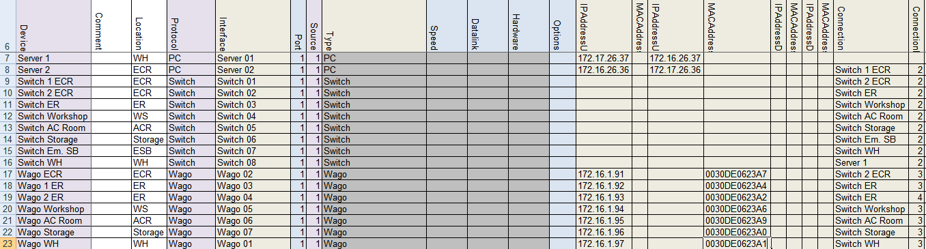

Figure 10‑28: Wago Addresses 3

The Network Serial connections need some special attention. Network Serial Connections can be a variety of interfaces with different approaches in the devicelist. In our example we have Moxa’s as interface. These Moxa’s have an Up-link and you need to specify the MAC address. Also you must specify the connection and the connection port.

According to Table 10‑6 the Moxa falls in the range of x.x.1.4y. so in this case, starting again in the ECR the first Moxa (Serial Network 01) will get the address 172.16.1.41 (as it exists in the 172.16.x.x. range.

*: if you use multiple ports on a Serial Network interface, make sure that you give the same IP address and MAC address to these ports as they are on the same interface.*

The MAC address range of a Moxa will probably be within the 0090E8 range. You’ll find it on the backside of the interface. Put it in the appropriate row.

The first Moxa we find in the ECR with the printer connected to it. This will get the address 172.16.1.41. While only one port is in use, we only need to fill in one row. See the following:

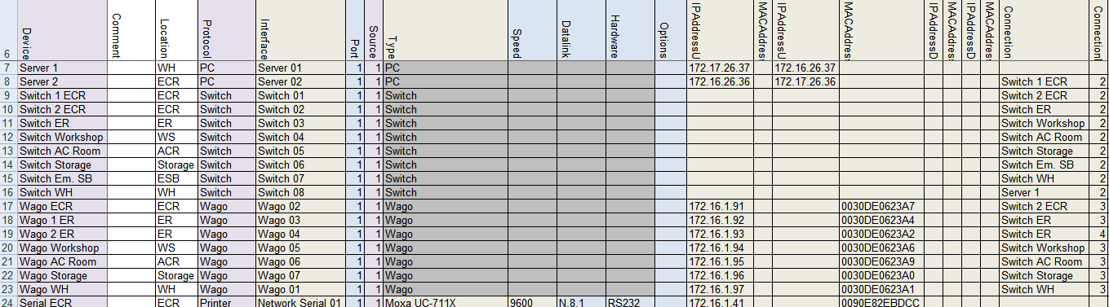

Figure 10‑29: Network Serial addresses 1

Now we can do that for the rest of the Network Serial connections. Be sure that you fill in the same addresses at multiple port connections.

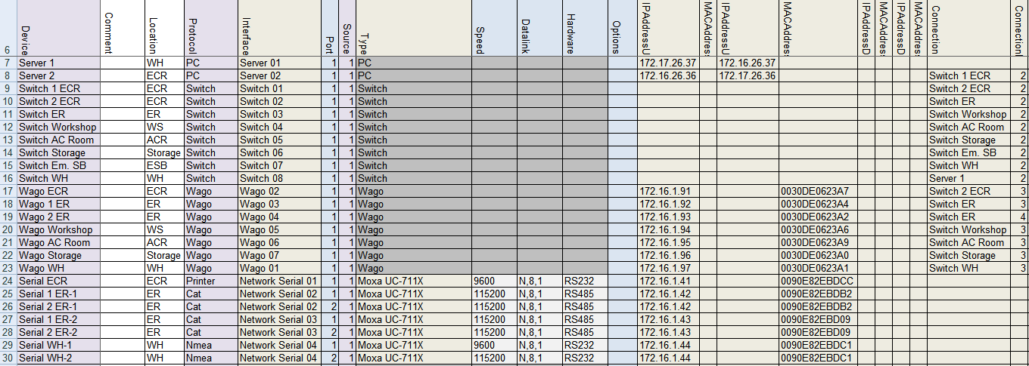

Figure 10‑30: Network Serial addresses 2

Finally assign the Connection and ConnectionPort Wher the ConnectionPort will be the first free port on the switch and you will get the following:

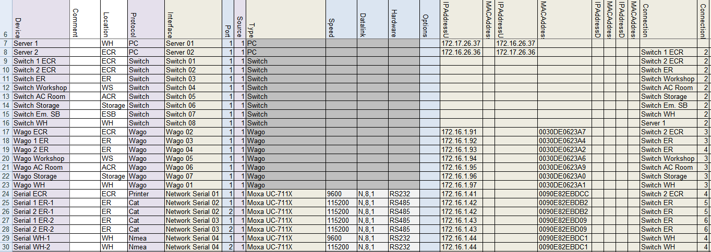

Figure 10‑31: Network Serial addresses 3

*: other Network Serial interfaces can be: ICPdas i7540D, Modbus TCP/IP, Serial TCP/IP and a few others. They mainly work the same way in the devicelist, with the exception that you don’t need a MAC address for TCP/IP.*

Finally we have a few clients in the single line drawing. These are the so called DAP’s (Duty Alarm Panels). As we know from Table 10‑6 the IP range for DAP’s lies within the x.x.1.8y range Where the first one will be x.x.1.81 and so on. While these DAP’s are also in the 172.16.x.x. range, the first DAP will get the address 172.16.1.81.

Also the MAC address is necessary so we put that in the devicelist (DAP’s are in the 00506C range) and also the Connection and ConnectionPort has to be put in. We will finish the devicelist like this:

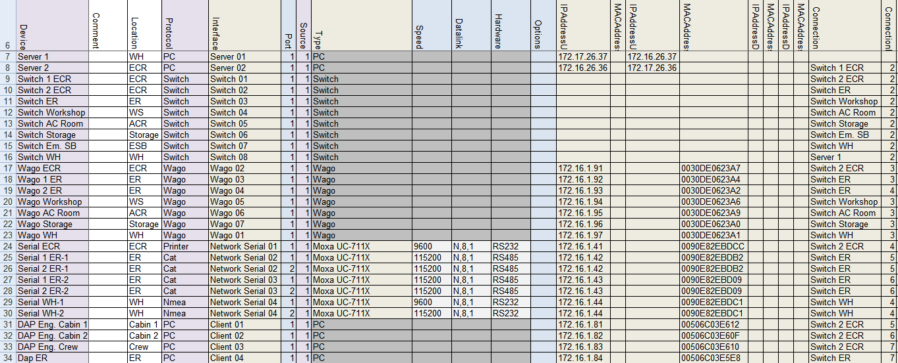

Figure 10‑32: Client addresses

Now the Devicelist is ready you can import it into NavVision to check if it works. We refer to Chapter 12 for further information.

*: We didn’t describe all the possibilities that you can change in the Devicelist, merely the basic ones. Other interfaces or devices can roughly be treated as we described above. If you do find something not working or don’t know how to implement that, please contact Free Technics.*